**NAME:** A. KAVIYA

**DEPARTMENT:** B.E. COMPUTER SCIENCE AND ENGINEERING

**COLLEGE: 8151-** DHANALAKSHMI SRINIVASAN INSTITUTE OF TECHNOLOGY SAMAYAPURAM TRICHY

**NAANMUDHALVAN COURSE:** DIGITALMARKETING

**NMID**: 53B3EA0AC66CF038C1843AEC81EBB088

**ASSIGNMENTS ON DIGITAL MARKETING**

1. **Create a blog or website using Blogspot and WordPress. Customizethe theme design and post a new article with 500 words.**

Blogspot URL - <https://avtypewriting.blogspot.com>

WordPress URL - [https://kaviyaasaithambi18.wordpress.com/2023/10/19/benefits-of-typewriting](https://kaviyaasaithambi18.wordpress.com/2023/10/19/benefits-of-typewriting/)

**2. Create a new Facebook Business Page and post one social media poster for your brand.**

Facebook Page URL -<https://www.facebook.com/avtypewritinginstitutes>

1. **Create and design a social media advertisement poster using canva**

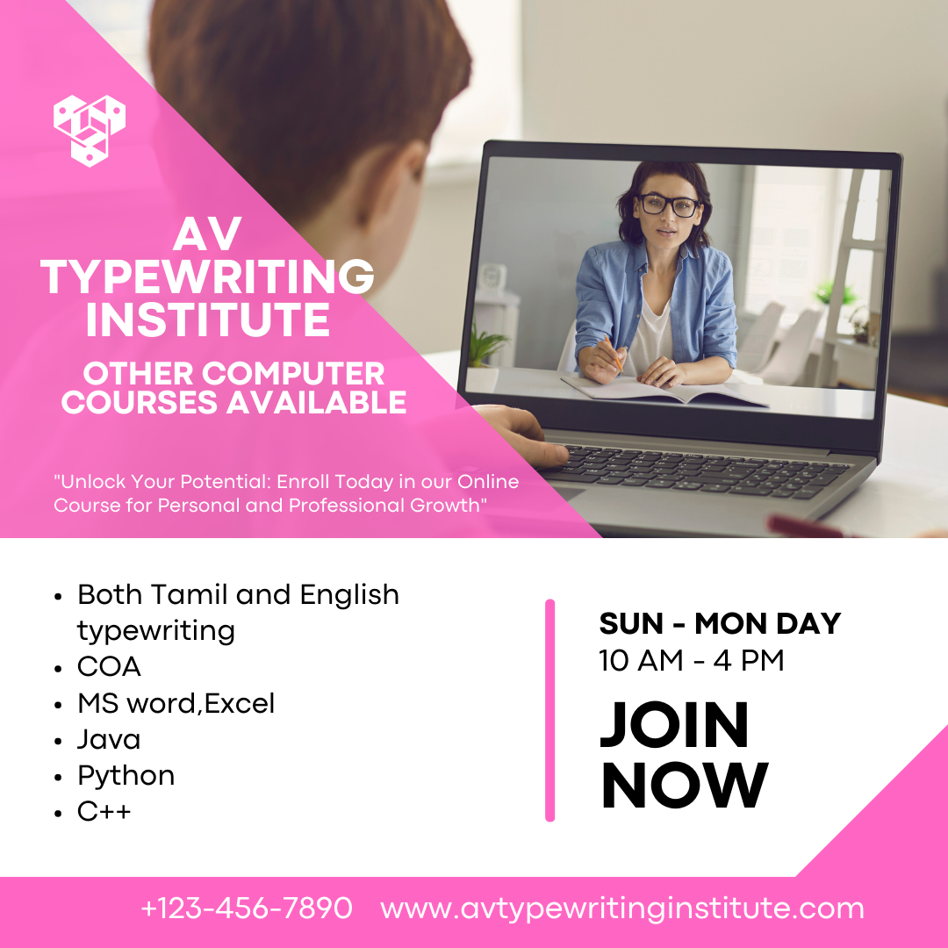

1. **Create email newsletter design using Mailchimp or Canva tool**

